Name:_____Markus Afonso______

**ASSIGNMENT 4** Set:___C________

**Due:** October 15th at 11:59 PM (for all three sets)  **Answer all questions on this handout.**

1. [5 marks] Use truth tables to prove or disprove the following Boolean statement:

𝑥(𝑦 ⊕ 𝑧) + 𝑥′𝑦′𝑧 = ((𝑥 + 𝑧) ↑ 𝑦)⊙ 𝑧

1. [15 marks] Use Boolean algebra to prove or disprove the following Boolean statements.

Circle the correct answer in each case and also show your work.

* 1. (𝑎′ + 𝑐′)(𝑎𝑐 + 𝑏′)′(𝑎 + 𝑏 + 𝑐′) = (𝑎𝑐)′𝑏 Proved Disproved



* 1. 𝑎’(𝑎 + 𝑏) + (𝑏 + 𝑎𝑎)(𝑎 + 𝑏’) = (𝑎 + 𝑏) Proved Disproved



* 1. ((𝑎𝑏𝑐′)′ + 𝑎′𝑐′𝑑′ + (𝑎′𝑏′𝑐′𝑑)′)′ = 1 Proved Disproved



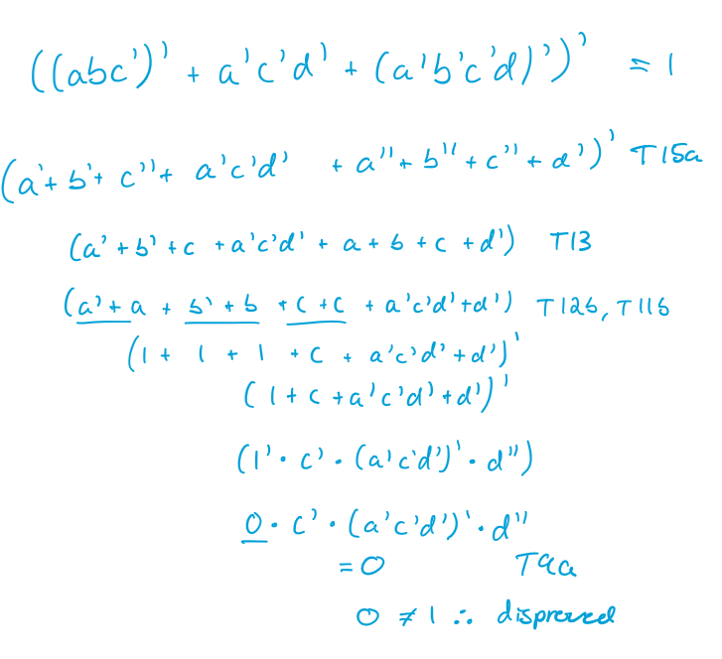

1. [15 marks] Simplify the following expressions as much as possible. Box your final answer.

* 1. (𝑦𝑧 + 𝑦′ + 𝑧′)𝑥

* 1. pq + q + 𝑝(q + 𝑟) +qr

* 1. (𝑥 + 𝑦)′ ∗ (𝑥′ + 𝑦′)

